si

Data Analysis and Visualisation Tool

User Manual

Stephen Urquhart

2810ICT Software technologies  Griffith University – Gold Coast

Table of Contents

Introduction 2

What is DAVT? 2

Features and Benefits 4

Features: 4

Benefits: 7

User Interface 8

Dashboard 8

Navigation 9

Troubleshooting and FAQs 12

Troubleshooting: 12

FAQs: 13

Closing Remarks 15

# Introduction

Welcome to the Data Analysis and Visualisation Tool (DAVT). This tool empowers New York City restaurant owners and health inspectors to analyse and visualise restaurant inspection results. Whether you're a health inspector responsible for conducting inspections or a restaurant owner looking to track trends, DAVT provides you with the data and insights you need.

DAVT's intuitive and user-centric design ensures that these powerful features are easily accessible, making it a valuable tool for anyone involved in providing food safety standards in New York City. With DAVT, you can transition seamlessly between raw data views and visualisations, enabling data-driven decisions without overwhelming complexity. Explore DAVT and experience the convenience of streamlined data analysis and visualisation.

### What is DAVT?

The Data Analysis and Visualisation Tool (DAVT) is a robust and user-friendly software solution that caters to New York City health inspectors, restaurant owners, and data analysts' unique needs. DAVT offers many powerful features and functionalities that empower users to gain valuable insights from New York City's restaurant inspection data. Here's a more detailed exploration of what DAVT can do:

#### Retrieve Inspection Details for a Specified Period

DAVT provides seamless access to comprehensive inspection details for a specific time frame. Whether you need to review recent inspections or dive into historical data, you can effortlessly retrieve the information you need to make informed decisions.

#### Visualise Violation Distribution Across Different Suburbs

Understanding the geographical distribution of violations is crucial for health inspectors and restaurant owners. DAVT offers a powerful visualisation feature that allows you to plot violations on a map, making it easy to identify areas with higher infringements. This visual representation simplifies decision-making and resource allocation for inspections.

#### Search for Violations Containing Specific Keywords

The keyword search functionality in DAVT enables you to conduct precise and targeted investigations. Whether you are a health inspector looking for instances of "rodents" or a restaurant owner concerned about "contamination", DAVT lets you quickly retrieve a list of violations that match your chosen keywords. This feature streamlines your efforts and saves valuable time.

#### Analyse Trends Related to Animal-Related Violations

For health inspectors and data analysts tasked with addressing animal-related violations, DAVT offers an intuitive platform for in-depth analysis. You can examine trends over time, identifying patterns in cases involving rodents, pests, and other animals. DAVT's analysis tools provide statistical insights and help you develop strategies for tackling animal-related issues effectively.

#### Evaluate the Top 100 Places with the Most Improvement

Continuous improvement in food safety standards is a priority. DAVT supports this goal by allowing users to evaluate the top 100 places with the most improvement over the last year for each borough. This information empowers health inspectors and restaurant owners to recognise and reward establishments that have made significant strides in enhancing their practices.

# Features and Benefits

## Features:

#### Intuitive Dashboard

DAVT boasts an intuitive, user-friendly dashboard that is your gateway to essential insights. The dashboard is thoughtfully designed to provide critical metrics and visualisations immediately. It presents complex data in a clear and digestible format, ensuring you can quickly grasp vital information.

#### Flexible Date Range Selection

Customisation is critical to practical analysis, and DAVT offers a flexible date range selection feature. Tailor your analysis by choosing specific date ranges that align with your objectives. Whether you need to focus on recent data or dive into historical trends, DAVT empowers you to explore the data on your own terms.

#### Keyword Search

Efficiency is paramount when searching for specific information within vast datasets. DAVT simplifies the process by providing a robust keyword search functionality. Enter keywords such as "rodent" or "contamination," and DAVT will swiftly retrieve a list of violations that match your search criteria. This feature enables you to conduct targeted investigations with ease.

#### Animal Analysis

For health inspectors and data analysts tasked with addressing animal-related violations, DAVT offers a dedicated platform for comprehensive analysis. Dive deep into trends related to animal-related violations, including cases involving rodents, pests, and other animals. DAVT's analysis tools provide statistical insights, empowering you to develop effective strategies for addressing these issues.

#### Violation Distribution

Understanding the geographical distribution of violations is critical for effective decision-making. DAVT simplifies this process by offering a violation distribution feature. Generate graphical plots that showcase the issuance of violations across different suburbs for your selected period. This visual representation lets you identify areas with higher violations and strategically allocate inspection resources.

#### Responsive Design

In today's diverse digital landscape, users access applications on various devices with different screen sizes. DAVT addresses this by incorporating a responsive design. Whether using a desktop computer, tablet, or smartphone, DAVT ensures a consistent and user-friendly experience, adapting seamlessly to different screen sizes and orientations.

#### Scalability

As your data needs grow, DAVT grows with you. It is designed to support concurrent usage by multiple users without compromising performance. Additionally, DAVT's backend architecture is built to accommodate increasing data volumes. This scalability ensures that DAVT remains a reliable and efficient tool as your data analysis requirements expand.

## Benefits:

#### Simplifies Data Access and Analysis

DAVT simplifies accessing and analysing data for both health inspectors and restaurant owners. Its user-friendly interface and streamlined functionalities facilitate data retrieval and analysis, eliminating unnecessary complexity.

#### Enables Data-Driven Decision-Making

Informed decisions are crucial for maintaining food safety standards. DAVT empowers users to make data-driven decisions by providing clear insights and visualisations. Whether you're a health inspector prioritising inspections or a restaurant owner enhancing safety practices, DAVT equips you with the data you need.

#### Provides Clear Visualisations

Clear and concise visualisations are instrumental in identifying trends and patterns. DAVT's graphical representations make spotting critical insights within the data easy. These visualisations enhance your ability to understand and act upon the information presented.

#### Allows for Quick Switching Between Views

DAVT's user-centric design facilitates swift transitions between raw data views and visualisations. This feature enables users to toggle seamlessly between different perspectives, ensuring a comprehensive understanding of the data without unnecessary navigation complexities.

#### Streamlines the Analysis of Vast Datasets

Analysing extensive datasets can be overwhelming. DAVT streamlines this process, making it manageable and efficient. Users can explore large volumes of data without feeling inundated, thanks to DAVT's intuitive functionalities and organised presentation.

# User Interface

The DAVT user interface is designed for ease of use and efficient navigation. It consists of several components:

## Dashboard

Displays key metrics and visualisations of inspection data.

Provides a platform for easy navigation and a linear workflow.

#### Date Range Selectors

Allows you to select specific date ranges for analysis.

Customisable to focus on recent or historical data.

#### Keyword Search Functionality

Let’s you search for violations based on specific keywords.

Provides filtered results for targeted investigations.

#### Animal Analysis Section

Allows you to analyse trends related to animal-related violations.

Provides insights into the distribution of such violations across neighbourhoods.

#### Violation Distribution

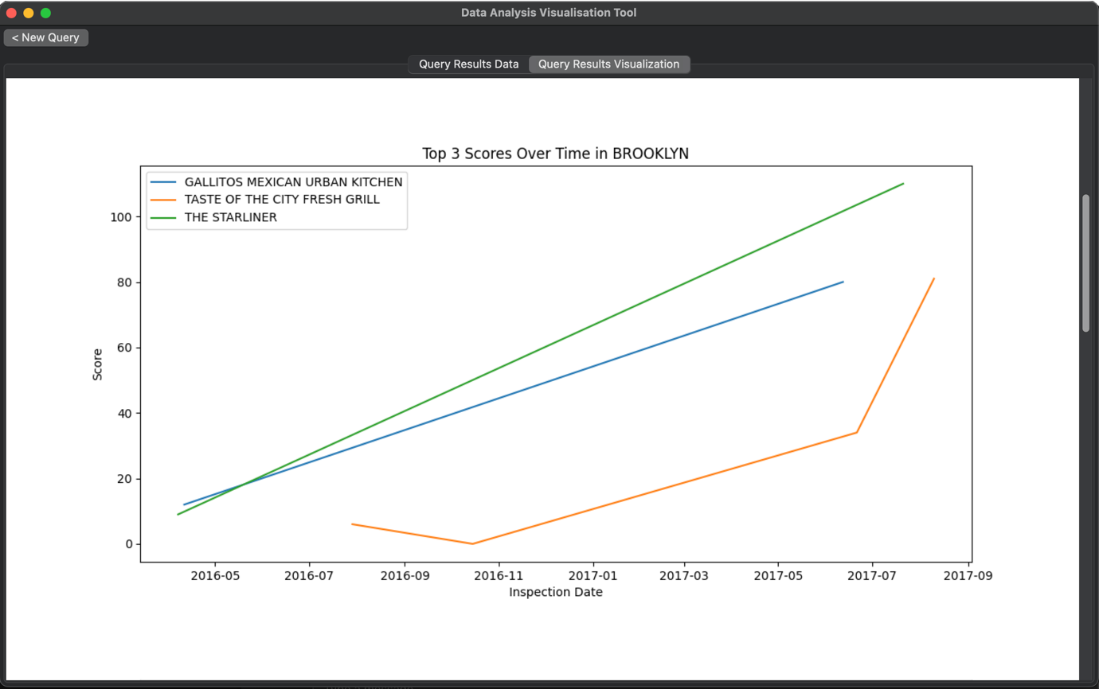

Generates graphical plots showcasing violation distribution across different suburbs for the selected period.

Helps identify areas with higher instances of violations and make data-driven decisions.

## Navigation

Easily switch between the home page, data result page, and data visualisation page.

Access the last query by using the "current query" button.

#### Dashboard

The dashboard serves as your entry point and provides valuable insights at a glance. It includes key metrics and visualisations related to restaurant inspections. The dashboard is designed for easy interpretation, allowing you to make informed decisions promptly.

#### Date Range Selectors

Customise your analysis by selecting specific date ranges. The date range selectors enable you to focus on the time frame that matters most to your investigation. You can view recent data or analyse historical trends.

#### Keyword Search Functionality

Use the keyword search functionality to retrieve violations containing specific keywords. Enter keywords like "rodent" or "contamination," and the tool will display a list of violations that match your search criteria. You can also filter the results and export the data for further analysis.

#### Animal Analysis

The animal analysis section is designed to help you analyse trends related to animal-related violations. Explore cases involving rodents, pests, and other animals and their distribution across neighbourhoods over time. Customise your analysis parameters to gain valuable insights.

#### Violation Distribution

The violation distribution feature generates graphical plots showcasing the distribution of violations across different suburbs for the selected period. This visualisation helps you identify areas with higher instances of violations and make data-driven decisions.

# Troubleshooting and FAQs

This section addresses common issues users may encounter using the Data Analysis and Visualisation Tool (DAVT). Additionally, we answer frequently asked questions to help you effectively resolve any challenges you may face.

## Troubleshooting:

Issue 1: DAVT Doesn't Start

Possible Solution: Ensure you have Python installed on your system. Check the Python version; DAVT requires Python 3.6 or later. Activate your virtual environment if you're using one.

Issue 2: Error Messages During Installation

Possible Solution: Check your internet connection. Ensure you have administrative privileges if you encounter permission errors during installation. If dependencies fail to install, consider using a package manager like `conda` or manually installing missing packages.

Issue 3: Problems with Database Configuration

Possible Solution: Double-check your database configuration settings, including host, username, and password. Verify that the database server is running and accessible. Ensure the database schema is correctly set up.

Issue 4: Slow Performance

Possible Solution: If DAVT is slow to respond, it may be due to the size of the dataset or system resources. Consider optimising your database queries or upgrading your hardware for better performance.

Issue 5: Visualisations Not Displaying Correctly

Possible Solution: Check your internet connection and browser settings. Ensure you're using a modern and up-to-date web browser. If issues persist, review the data being visualised and the parameters used.

## FAQs:

Q1: Can I run DAVT on a Mac computer?

Answer: Yes, DAVT is compatible with macOS. Ensure you follow the installation steps outlined in the user manual for macOS systems.

Q2: Can I analyse data from a different city using DAVT?

Answer: DAVT is designed specifically for New York City restaurant inspection data. While you can modify the tool to work with other datasets, its features are optimised for NYC data.

Q3: Is DAVT available as a mobile app?

Answer: Currently, DAVT is designed as a web application and is accessible through web browsers on various devices, including smartphones and tablets.

Q4: How can I export the visualisations generated in DAVT?

Answer: DAVT provides export options for visualisations. Look for export buttons or options within the visualisation interface, typically allowing you to save the visualisations as image files (e.g., PNG) or export data tables.

Q5: Can multiple users access DAVT simultaneously?

Answer: Yes, DAVT is designed to support concurrent usage by multiple users. It includes user management features to control access and permissions.

Q6: How often is the dataset updated in DAVT?

Answer: The dataset used in DAVT may have different update frequencies. It depends on the source of the data. Check the data source documentation or system settings for updated schedules.

Q7: What should I do if I encounter an error message in DAVT?

Answer: Review the error message carefully. It may provide specific details about the issue. Check the troubleshooting section in the user manual for potential solutions. If the problem persists, consider seeking assistance from technical support or the DAVT community.

Q8: Can I customise the visualisations in DAVT to suit my needs?

Answer: DAVT aims to provide flexibility in visualisation. Explore the visualisation settings and options within the tool to customise the visuals based on your preferences and analysis requirements.

Q9: Is there a user guide or documentation for DAVT available?

Answer: The user manual provided by DAVT offers comprehensive guidance on using the tool's features and functionalities. You can also refer to additional documentation or support resources for more in-depth information.

Q10: How can I provide feedback or request new features for DAVT?

Answer: DAVT values user feedback. Check for feedback channels within the application or contact the support team or development community to share your suggestions and requests for enhancements.

If you encounter issues or have questions not addressed in this troubleshooting and FAQs section, don't hesitate to seek assistance from technical support, user communities, or the DAVT development team. We are committed to helping you maximise this powerful data analysis and visualisation tool.

# Closing Remarks

The Data Analysis and Visualisation Tool (DAVT) simplifies analysing and visualising restaurant inspection data, making it easier for health inspectors and restaurant owners to ensure food safety standards in New York City.

We encourage you to explore DAVT's capabilities and leverage its features to enhance your understanding of restaurant inspection data, make data-driven decisions, and contribute to improving food safety standards in America.

Your feedback and suggestions are valuable to us as we continue to enhance DAVT's functionality and usability. We hope that DAVT proves to be a valuable tool in your data analysis and visualisation endeavours, and we look forward to assisting you in your data-driven journey.